# Managing Photopoint Photos, Watermarking and Metadata

This document details my script for (mostly) automating the management of photos submitted by Photopoint members to make GO life a little easier.

It assumes that photos will be submitted by uploading to Google drive.

Photos will be watermarked with the photographer's name, resized as necessary, renamed to a consistent format, and basic keywords (photographer's name, BFS and festival generic keywords) added. Adding keywords that are specific to a particular shoot or to particular groups is assumed to be the photographer's responsibility.

The script runs on Google Colab. This document assumes no knowledge of Google Colab, nor of programming. The script also details how Google Drive should be organised to make life easy.

# 

# Getting your own copy of the Colab Script

This part should only need to be done once.

Log in to the Photopoint account on Google Drive then go to

<https://github.com/Photopoint/metadata/blob/main/Photopoint_Metadata.ipynb>

This is the master copy of my script to automatically watermark, resize and add metadata to Photopoint images.

Near the top of that page should be a button saying "Open in Colab". Click on that and it will open the script in Google Colab.

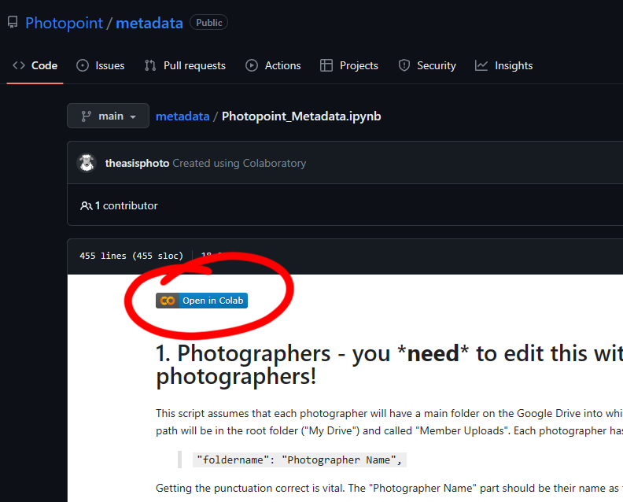

You need to make your own copy for Photopoint use. Do this by clicking on:

**File -> Save a copy in Drive**

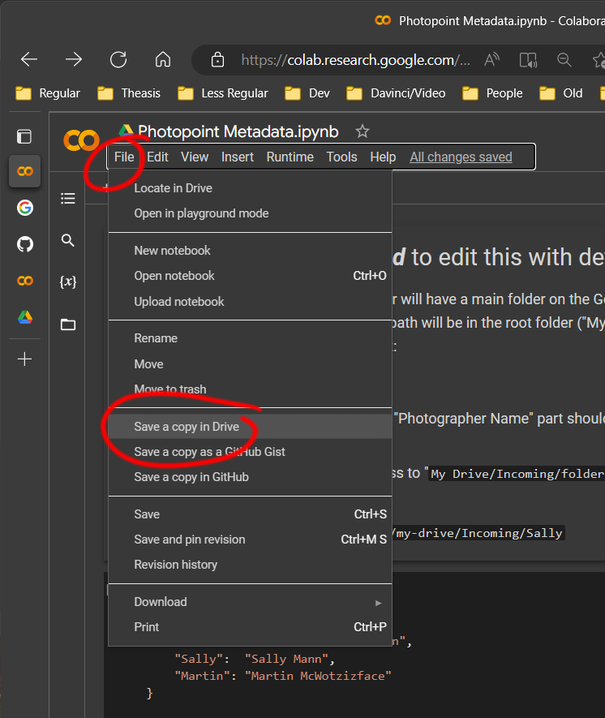

Now you can close this Colab window and you shouldn't need to access it again.

There should now be a folder in the Photopoint **My Drive** called "**Colab Notebooks**". Your copy of the script should be there. We'll come back to this in a moment.

# Setting Up the Photopoint Google Drive

This part should also only need to be done once (per festival).

I set up the Colab script assuming that the Photopoint Google Drive will be set up such that there are folders called "**Member Uploads**" and "**Processed Photos**" in the top level "**My Drive**". It doesn't matter what other random stuff you also have in **My Drive** so long as those two folders are there.

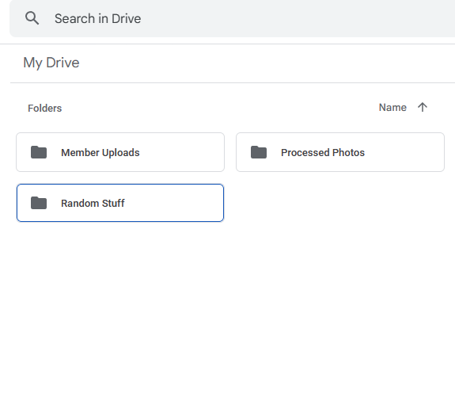

"**Processed Photos**" can be empty. The script will automatically put any processed photos in here. "**Member Uploads**" is where Photopoint members will upload their photos. There must be one folder in "**Member Uploads**" for each Photopoint member; they need to have read and write access to their particular folder (and shouldn't generally be given any access to any other parts of the Photopoint drive - but I'm not your boss ;-) ).

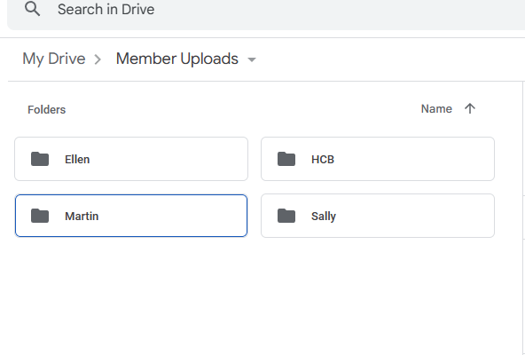

# 

# Setting Up The Script

This part should hopefully only need to be done once per festival, but will need to be revisited if you add more members to Photopoint.

Find the colab script in your **Colab Notebooks** folder and double-click it. The script should open in Google Colaboratory, which is a virtual computer on Google's servers.

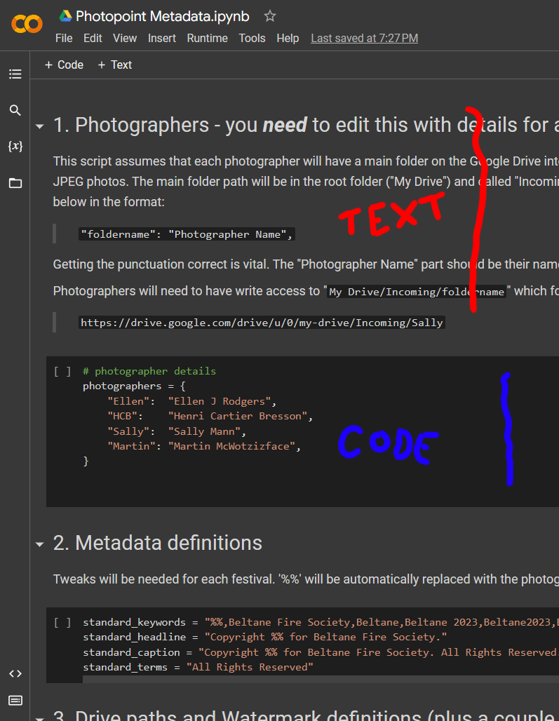

It contains a combination of documentation sections (mid-grey) with code sections (dark grey). I've numbered the sections.

Section 1 is where the photographer details are. This needs to be edited each festival, and whenever you add new photographers to Photopoint.

Section 2 contains the standard metadata that will be put into every photo. The headline, caption and terms might never need to be changed. The keywords will need to be edited once each festival, if only to change Beltane/Samhuinn and to keep the year correct. The text '**%%**' will be automatically replaced with the photographer's name when it is added to a photo.

Section 3 contains where things will be on Google Drive (this won't need to be changed unless you don't follow the suggestion in *Setting Up the Photopoint Google Drive* above), the size of social media files, the text of the watermark (again, '**%%**' will be automatically replaced with the photographer's name when the watermark is created), and the size of the watermark text (in points). You can have different size text on social media and archive files if you like.

Section 4 is the code that does all the work and shouldn't need to be touched.

Section 1 is where the important stuff - the photographer details - goes. Click on the dark grey area to put it into editing mode.

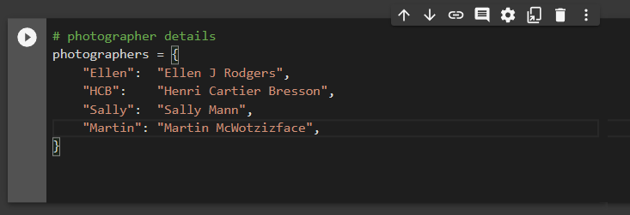

Only the section with brown text should be edited!

In the "**Member Uploads**" folder on Google Drive you should have one sub-folder per group member. The first part of this section is the sub-folder name (in double quote marks), followed by a colon, followed by the photographer's name as it will appear in the watermark (also in double quote marks).

Each of these lines starts with a "TAB" indent, the text is in double quotes, there is a colon between the two parts, and the line ends with a comma. This formatting is important!

Add a line for each of your photographers, with their designated folder name and the text they want on the watermark. Remove the nonsense examples that I put in there.

All the lines that you edit should stay between the two white curly braces.

Any changes you've made *should* be automatically saved, but make sure by clicking

**File -> Save**

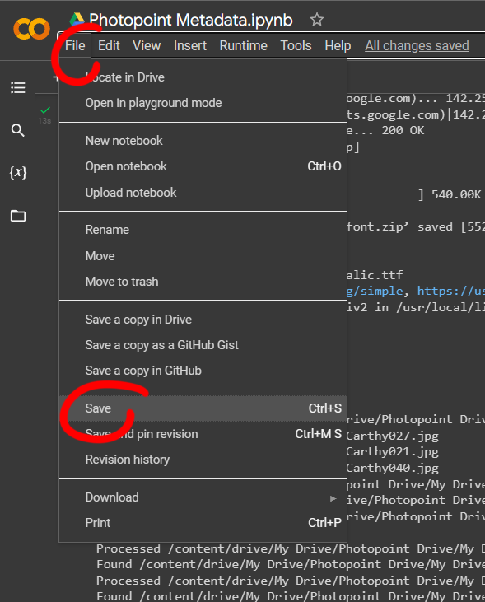

# Testing Your Changes

## First Test

Click on **Runtime -> Run all**

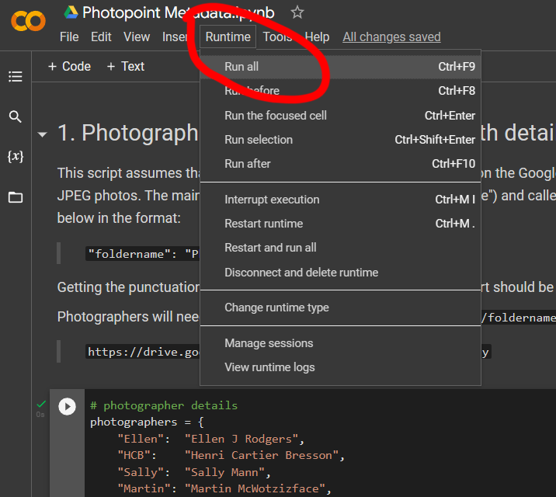

If all is good you should get a dialog saying that the script needs to connect to Google Drive. Click the Connect to Google Drive button.

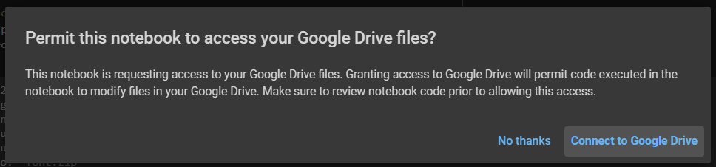

You should now get a request to choose a Google Drive account. Select the Photopoint account.

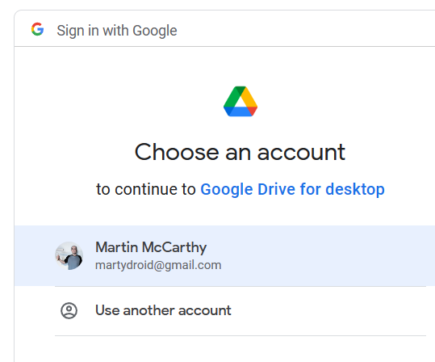

You'll now get yet another dialog saying that the script wants to access your account with a list of all the things that the script can do. If you trust that I'm not trying to do anything evil, scroll to the bottom of the dialog and click the **Allow** button.

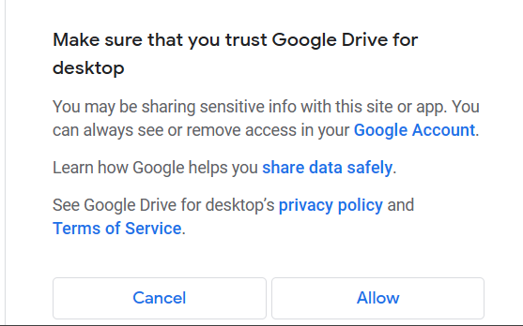

The script should now run. Scroll to the bottom of the colab page and you should see some output like this saying what the script has done:

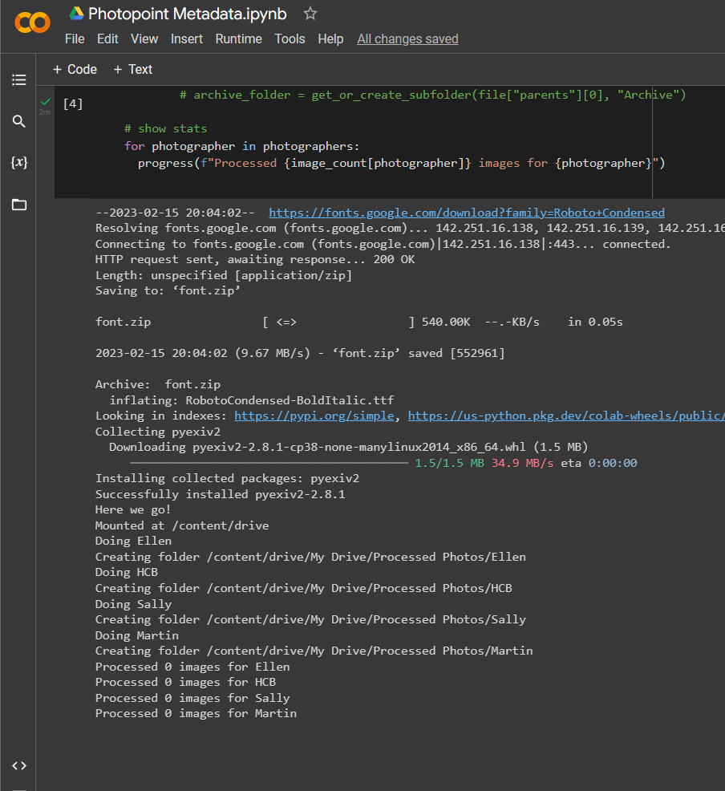

The very last few lines should be a summary of how many photos were processed for each of the photographers. In this case, none.

## Second Test

Create a sub folder under your own folder in **Member Uploads** and upload some jpg photos. Wait for the photos to finish uploading then click on **Runtime -> Run all** in the script window again. Scroll to the bottom of the script page and you should see some text showing the folders that have been created in **Processed Photos** and which images have been found. And the summary of images processed is hopefully no longer zero!

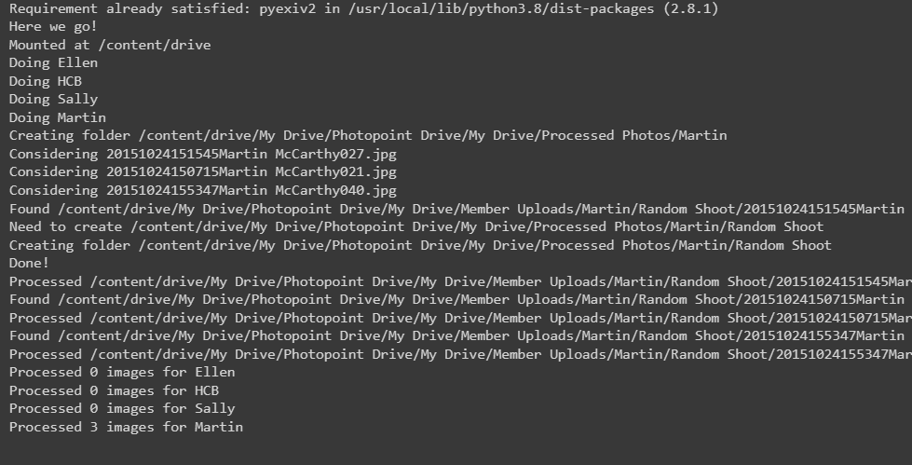

Looking in **Processed Photos** there are now sub folders matching those into which I uploaded my images and there are copies of the files I uploaded (they've been moved here - processed images will no longer be under the **Member Uploads** folder), plus full size ARCHIVE and resized SOCMED versions of the images with watermarks.

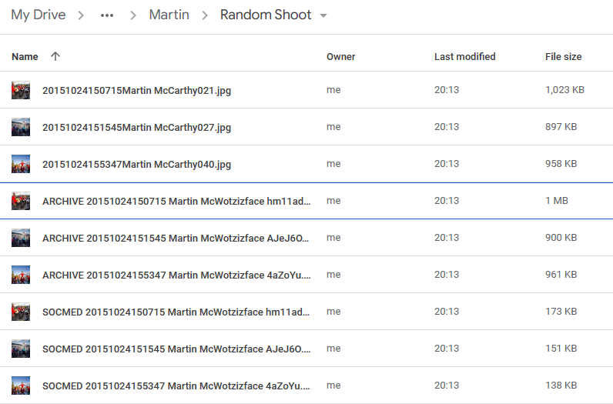

## Third Test

Have all your group members create sub folders in their personal **Member Uploads** folder and upload at least one edited jpg photo.

Run the script again with **Runtime -> Run all** and check that they all get correctly processed, watermarked, moved, and have the metadata added.

# Regular Use

In regular use, whenever you need to process photos that have been uploaded:

1. Go to the **Colab Notebooks** folder on the Photopoint drive and double click on the **Photopoint Metadata.ipynb** script (or whatever you might have called it when you copied it) to run it.
2. Click **Runtime->Run all** to run the script.
3. Scroll to the bottom of the script page to check everything got processed as expected.

If all went well, the original files will have disappeared from the members' personal upload folders (so they know they've been processed) and will have been copied to folders under **Processed Photos** along with **ARCHIVE** and **SOCMED** watermarked files.

The archive and socmed files will all have a standard naming, and if everyone's camera is synced to the same date and time they will sort in chronological order of when they were shot. The filename will be in the form:

type datetime photographer extra.jpg

where datetime is YYYYMMDDhhmmss.

For example:

SOCMED 20151024150715 Martin McWotzizface hm11ad.jpg

Those extra random characters on the end are just to make sure that each photo has a unique name even if you shot a burst of lots of photos in the same second and submitted them all.

# Changelog

## 2023-03-13

* Be case-insensitive when looking for .jpg files.

## 2023-05-23

* initialise the keywords with any tags that are already in the image being processed
* corrected documentation in section 1 to refer to the "Member Uploads" folder rather than "Incoming"
* added an option in section 3 "create_soc_med" to allow turning off the creation of social media resized files
* set the Image.MAX_IMAGE_PIXELS limit to allow images as large as 1 gigapixel before the "decompression bomb" warning is triggered

## 2023-05-28

* updated to link to the master copy of the script on Github rather than an old Colab script

## 2023-08-30

* added options in section 3 to allow socmed and archive files to have different text sizes for the watermark